Step 1: Use UltraVNC Viewer to login to the AWS server using the IP: 52.27.100.122:5904

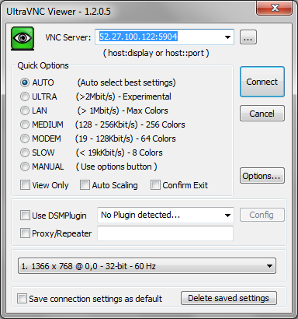

When prompted for a password, please enter: **centos**

2. We have two Docker containers running on the host OS,

The first container has the IP: 172.17.0.3, with the following software installed in it:

a. Jenkins

b. Mantis

**Evidence 6.** To access Jenkins, open firefox and type the following address:

http://172.17.0.3:8080/

You will see the home screen for Jenkins per the screenshot provided below

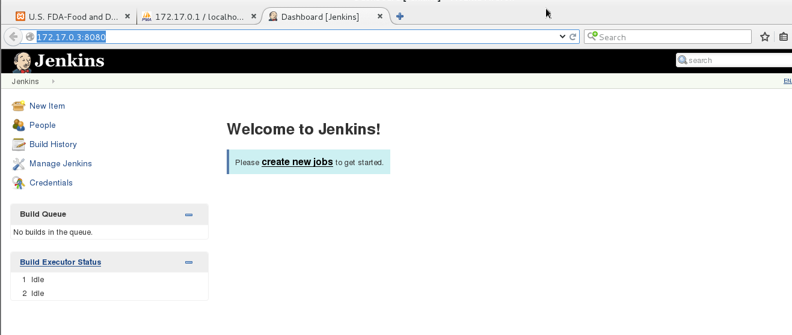

**Evidence 7.**To access Mantis, please open firefox and type the following URL:

<http://172.17.0.3/mantisbt/my_view_page.php>

You will see the home screen for Mantis per the below screenshot.

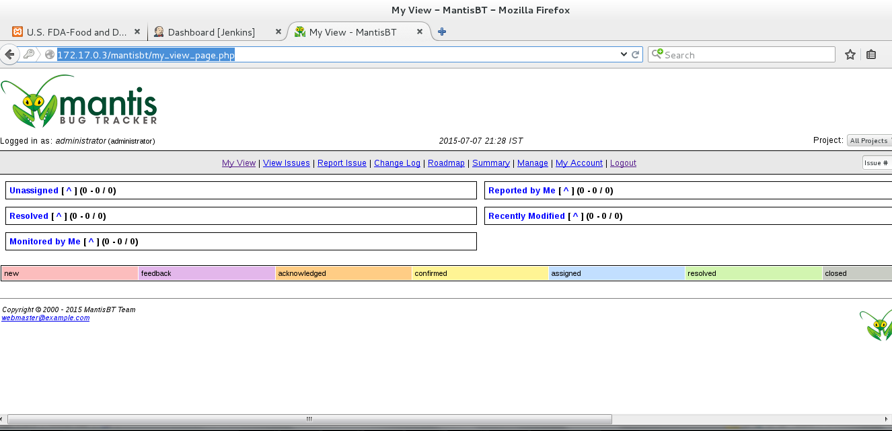

The second container has the following software installed in it:

a. MySQL Server with a Database containing the FDA data extracted from the OpenFDA REST API

b. Apache Web Server which hosts the FDA Dashboard

**Evidence 9.**Please use the following URL to goto the login page for the web application dashboard that we created and enter the below credentials:

URL: <http://172.17.0.1/openFDA/FDA#/Dashboard>

Username: admin Password: admin

Once you login, you will see the dashboard per the below screenshot

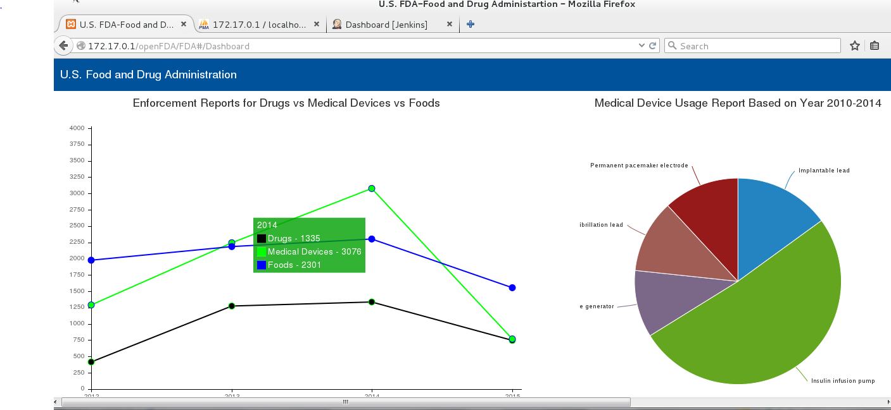

**Evidence 12.**The best and easiest way to port the web application to another platform is to save the second Docker container (172.17.0.1) as an image and porting it to an image hosting platform like DockerHub and then deploying the same to another host OS.